Main menu and adding 3 new items  
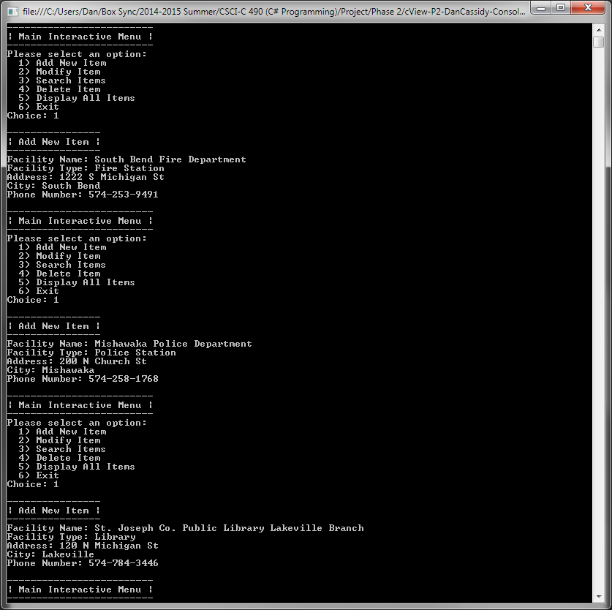

Attempting to modify an item: no input, cancelling, and invalid item number  
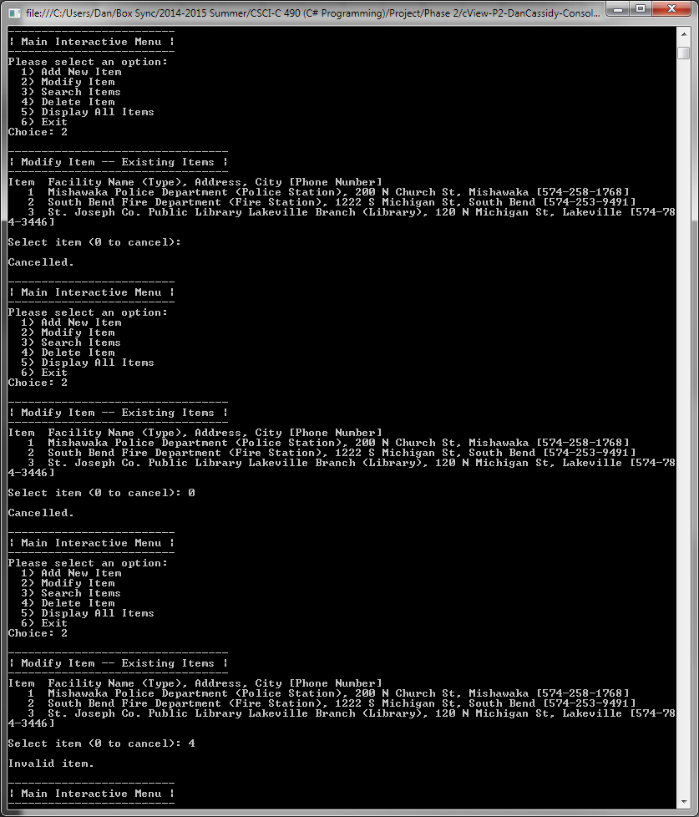

Modifying the name of one of the entries  
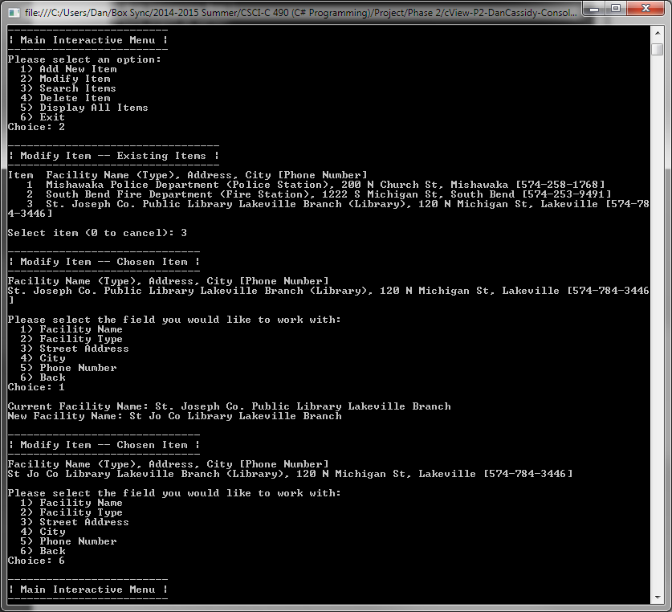

Searching for a city with a search string of “s”  
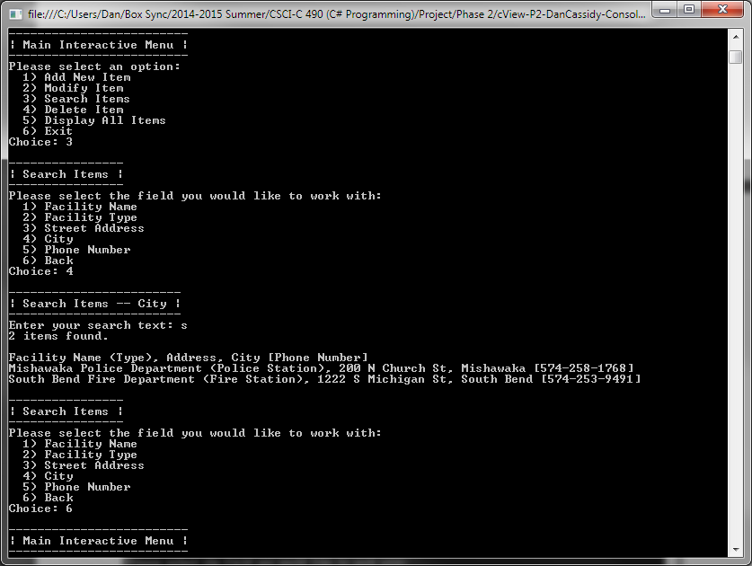

Display all items  
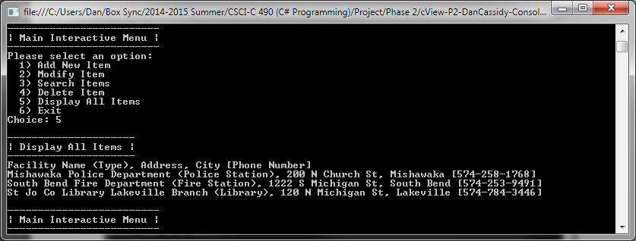

Attempting to delete an item: no input, cancelled, and invalid item number  
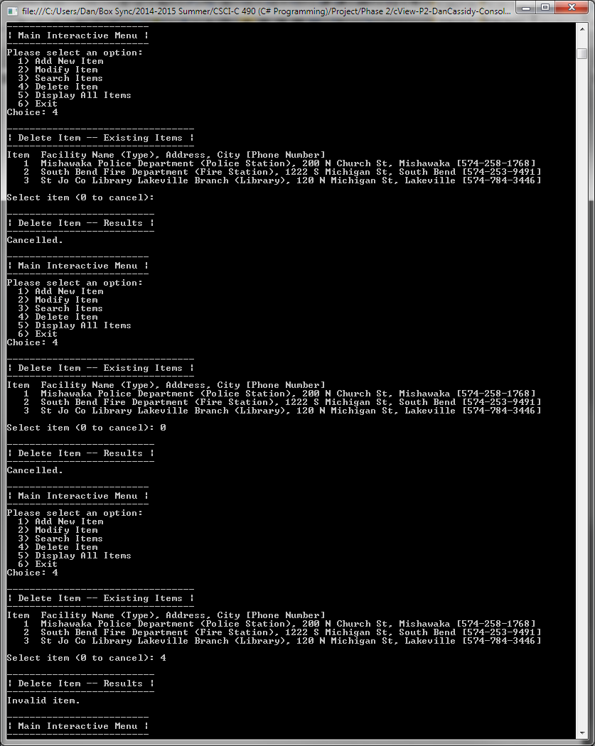

Deleting the items  
